**lntraday Profiles**

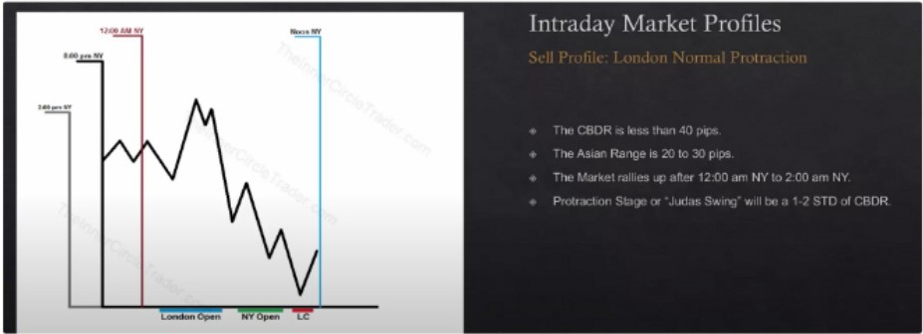

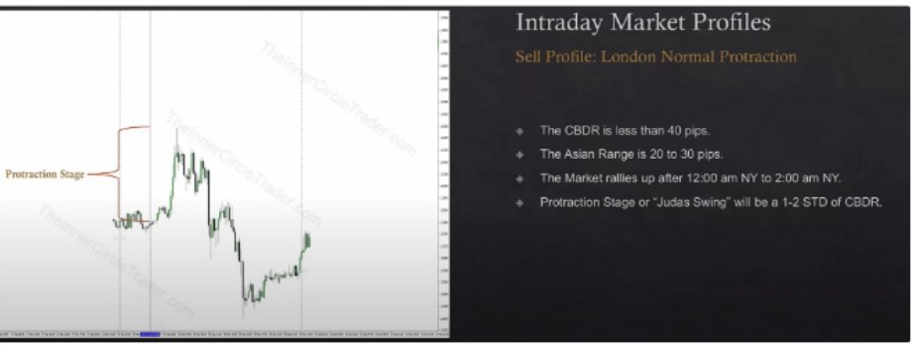

Classic sell day,

Theres going to be a lot of variations, they wont be the exact same everyday but they'll have similarities

These are filters, a checklist

If ICT doesnt see this then he wont engage in London

If CBDR is big thats going to mess up the float and youre probably not going to want to trade London, that can change if the asia is a small consolidation of max 20-30 pips. But don't use the CBDR measurements then?

The entry can occur as early as 1am or 1:30am We need to see a move up at 12am

Price movement at 1am till 1:30am it shouldve made a higher high than that what was seen in the asian range or CBDR thats the protractionary stage, ideally it will trade up from 12am to 2am

Its trapping early sellers

Sell profile London delayed protraction

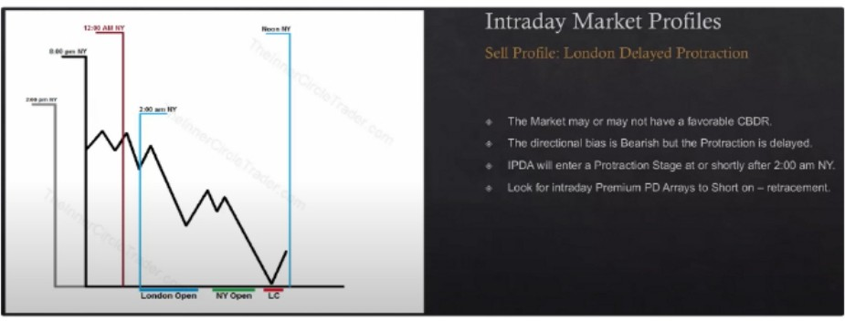

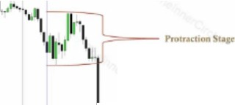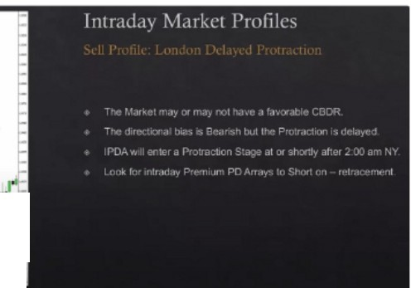

1.r

II11l •1PI•,1I"•'l**l'-,l""**.**'"**.**''L**r'

I

I.(

...

*�*

CBDR doesn't matter here

This is when 12am doesnt have a rally and just moves lower into 2am There must be a rally at 2am into a PD array, into a 15m PD array

Buy profile, classic

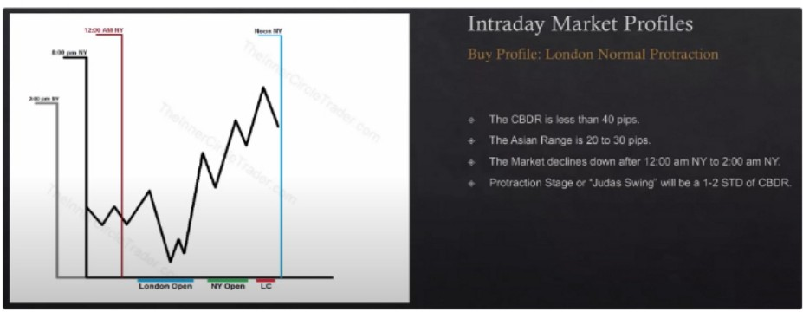

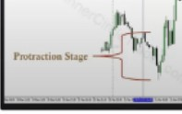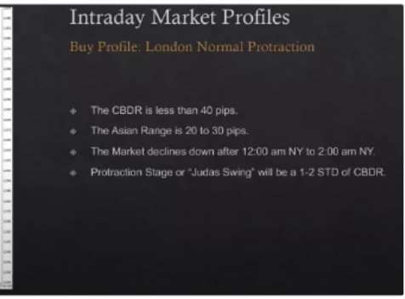

Seeing the decline is the most important to see which profile we apply

Decline atleast until 1am 1:30 am

Buy profile, delayed protraction

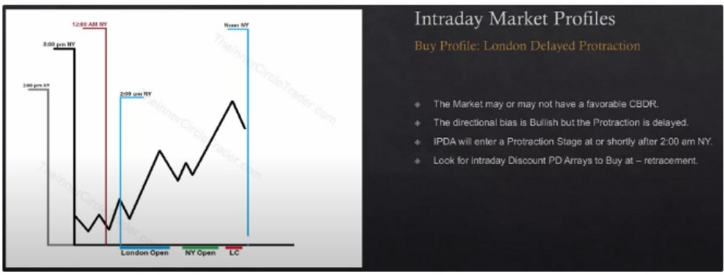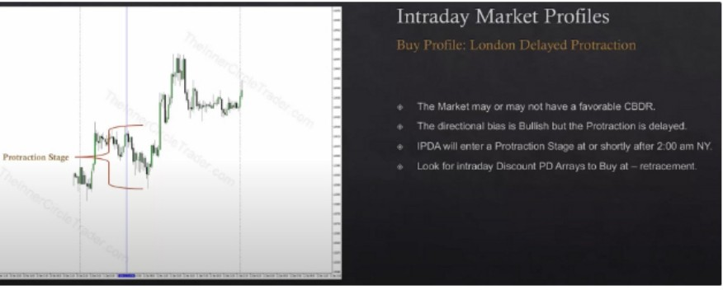

The asian range helps define this profile as well, if the asian range is small its more favourable. But its not mandatory, the profile can be seen with or without asia being in a range

Again the decline or rally at 12am is important to see what will happen. If the CBDR is not under 40 pips then we already move to this profile

If the classic profile is not there, then we look for justification of the delayed protraction. We either get the protraction at 12am or 2am

Be a buyer or seller based on the **HTF** premise

Sometimes it wont provide an entry and it will just take off, but thats okay. Were only trading high probability

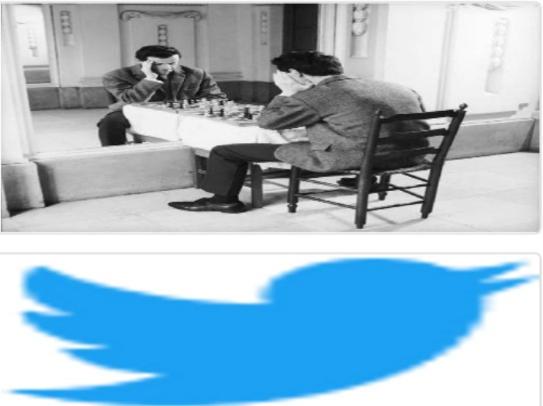Arjo I Twitter, lnstagram I Linktree

Linktree. Make your link do more.

, https://t.co/HhmmTN1fUI

JavaScript is not available.

***'!I*** https://twitter.com/arjoio